**BIG MOUNTAIN RESORT**

* Big Mountain resort, located in northwestern Montana, opened in 1947 with an annual snowfall of 333 inches and 3,000 acres of skier and rider accessible terrain. Big Mountain Resort offers access to 105 named trails and vast bowl and tree skiing.
* Big Mountain Resort offers access to 105 named trails and vast bowl and tree skiing. All these are serviced by 11 lifts, 2 T-bars and 1 magic carpet for novice skiers. The longest run is named Hellfire and is 3.3 miles in length.
* Big Mountain Resort has recently installed an additional chair lift to help increase the distribution of visitors across the mountain. This additional chair increases their operating costs by $1,540,000 this season. This business profit margin is 9.2% and the investors would like to keep it there.
* According to given dataset, it contains 27 columns which describes every equipment and attributes of different states and regions.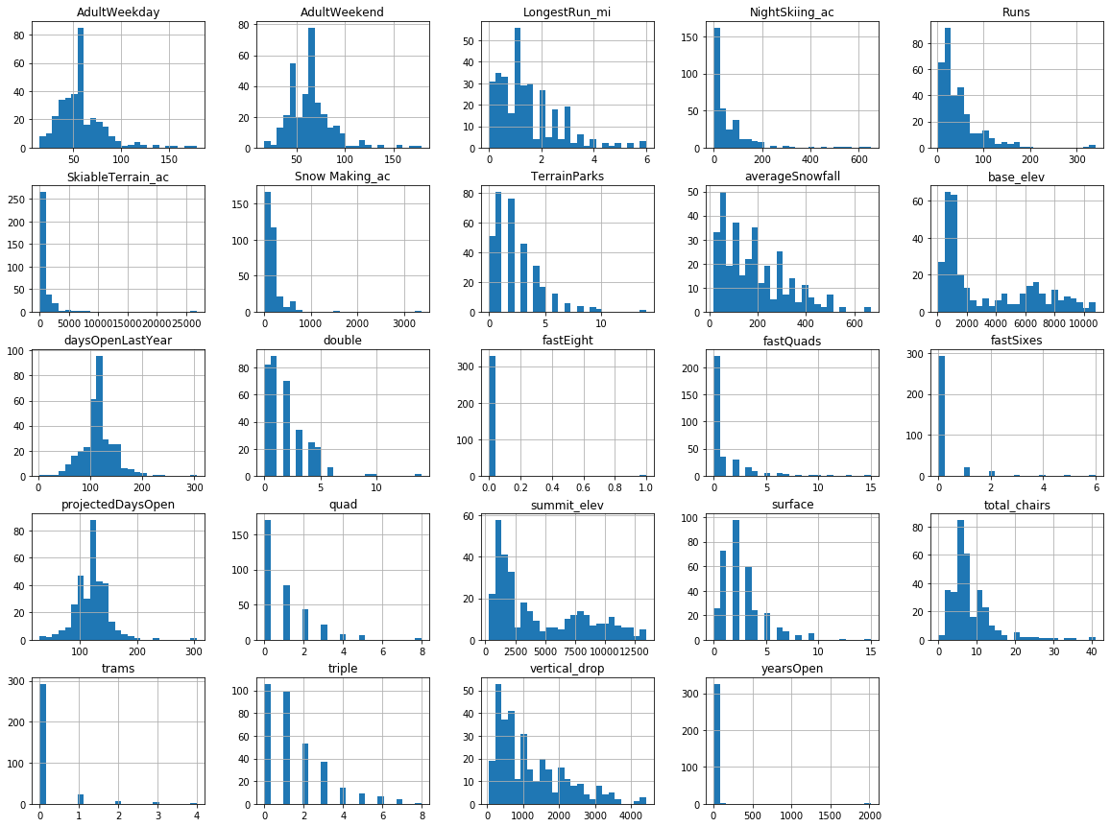
* After performing data science methods like data wrangling, exploratory data analysis, some anomalies and outliers found which leads to over estimation and effects the recommendations. These outliers removed by implementingdata cleaning methods.

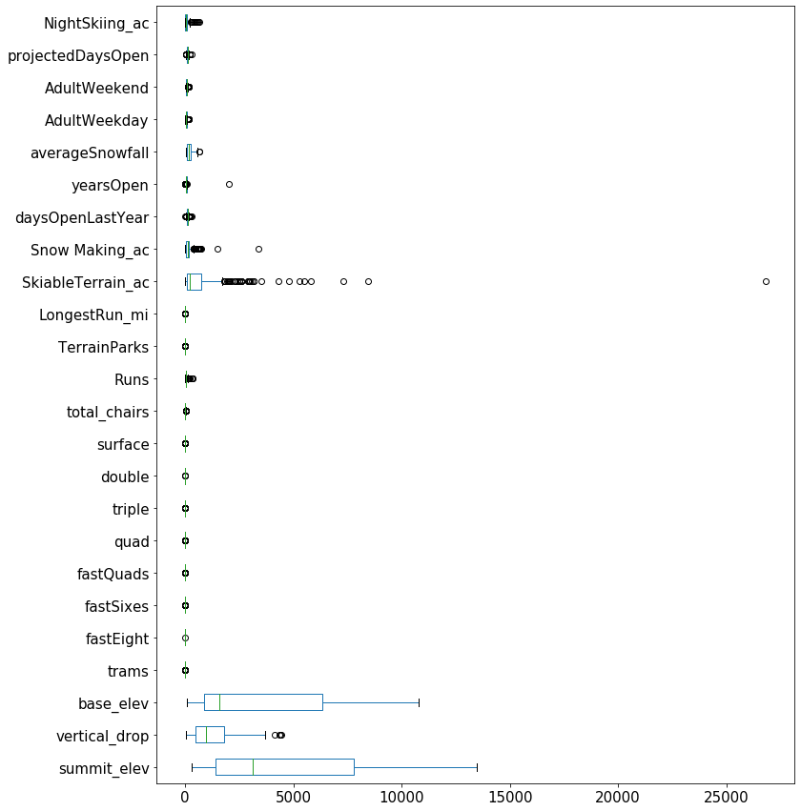

* EDA gave an insight to maintain the business profit to maintain 9.2% by increasing the Adultweekend price.
* Preprocessing and data training methods were implemented and data modelling with linear regression carried out with splitting all columns to ‘X’ except AdultWeekend column to ‘y’.

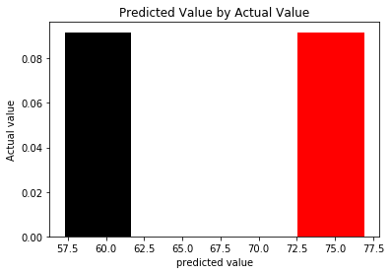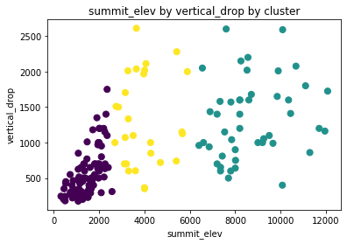

* After the modelling the data set with plots it is recommended to increase the **adult Weekend price** to maintain the profits as mentioned.